Professional | 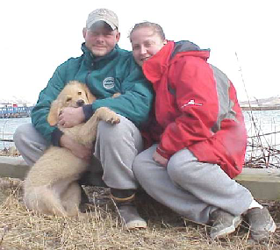
Bio Sheet
 | Sean, Karin, and Attu

As proud Alaskans working in the seafood industry, we are frequently shocked at what we see for sale in grocery stores and restaurants sold as "Alaska Seafood". Quality issues such as Freezer Burn, Freshness, and poor workmanship sold all over the United States is both embarrassing and sad.
We at Aardvark Seafoods provide our customers with the best Alaska Seafood at a reasonable price. Our fishermen are paid a premium for their services and are discriminating and concerned about the product they provide. Aardvark Seafoods and our fishermen abide by all Alaska Quality Seafood Standards as well as ASMI Guidelines. With our combined quality assurance backgrounds, we won't sell any products that we wouldn't throw on our own barbeque.
We provide the best, guaranteed!
Sean Crosby & Karin Holbrook

Sean Crosby:
Sean Crosby began his career in the Alaska Fishing Industry working on the ‘slime line’ on an offshore processing vessel. Onshore, he later worked for Ward’s Cove as a production foreman as seasons dictated at various sites around Alaska and also as a Fish Meal Plant Operator for Alyeska SeaFoods in Dutch Harbor, Alaska. In 2000, he began working for an independent seafood quality and water quality inspection company.

Karin Holbrook:
Since 1992, Karin has worked in the Alaska Fishing Industry in the following capacities:
Presently, Karin is director/manager of a self-maintained seafood quality inspection and ADEC certified water analysis laboratory;
An Alaska Salmon Quality Program instructor.
Certified in HACCP/SSOP plan compliance issues;
Off-shore/On-shore seafood processor;
On-shore administrative receptionist;
A Shipping Manager;
A Shop Steward for Alaska Fishermen's Union;
A Quality Control Technician;
ADEC drinking water Microbiology, 2001.

Attu:
A Golden Retriever, Attu was born in Dutch Harbor, Alaska and shortly after joined the family in December 2002.

